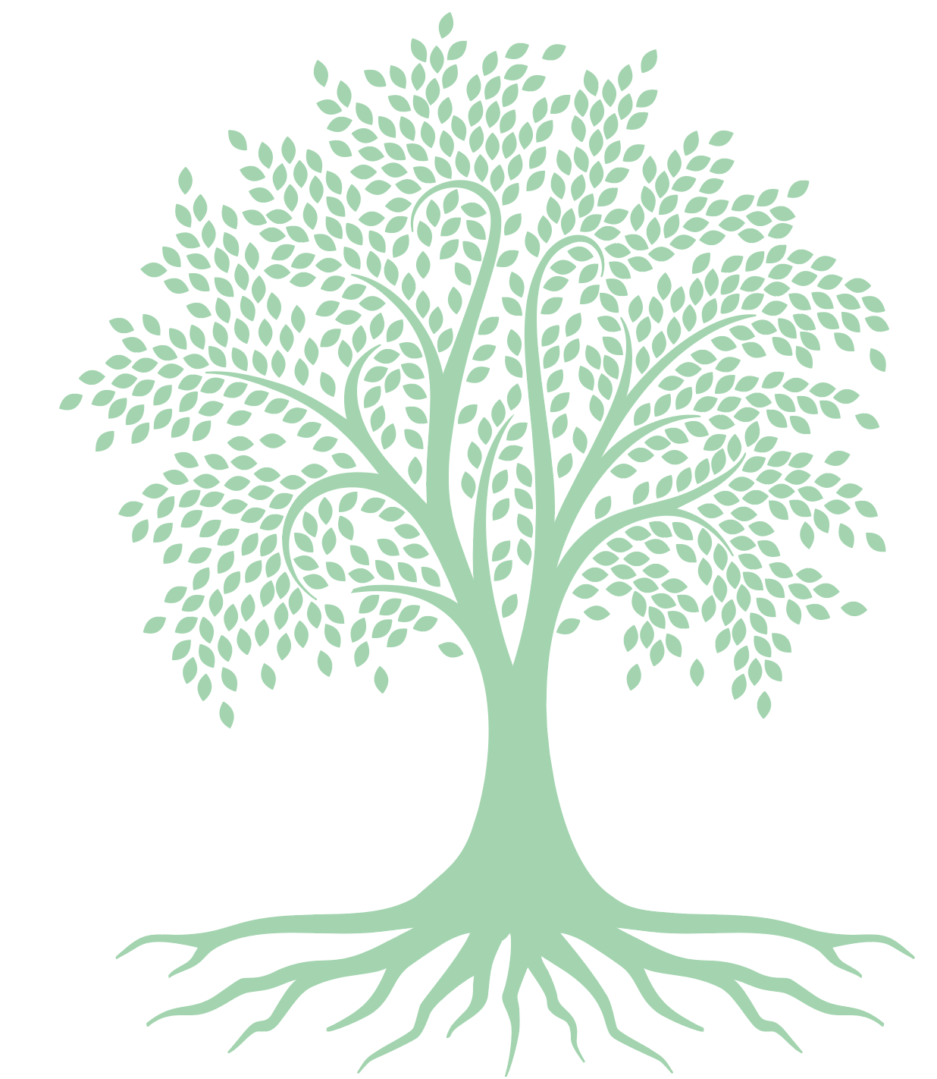
MINDFULNESS
Cindy Senk M.ED Rehabilitation
RYT-200, Certified Personal Trainer
Movement for All

Mindfulness Definitions:
- Mindfulness is letting go of taking things for granted.
- Mindfulness is returning to the present moment.
- To be alive is to totally and openly participate in the simplicity and elegance of here and now. -Donald Altman

Seated or reclining whole body guided relaxation:

Ask participants to find a comfortable place to sit or recline. Settle, center, focus on your breath, close your eyes or take a soft gaze to the earth
- Envision a beautiful pot floating above your head. It is filled with honey, or sunshine, or moonbeams...whatever the participant desires
- Imagine the honey flowing into the top of your head spreading warmth, pain relief, calmness in your head and neck area…
- The honey continues to flow down both arms to your fingers spreading wonderful healing energy wherever it goes…
- Continue this theme as you guide them through the entire body ending with the feet and toes.

Close the guided relaxation with these words of loving kindness:
- May you be loved and loving
- May you be safe from harm
- May you be as healthy as you can be in this moment
- May you be at ease and happy...

Meditation/Mindfulness Apps:
CALM HEADSPACE MINDFUL MAGIC

